Collaborative Augmented Reality Tracking, Interaction, and Display for mobile game

Qiang Fu

September 13, 2016

# INTRODUCTION

## Background

Although Augmented Realit (AR) technology has existed for decades, it is by far one of the hottest tech topics in 2016. AR is hanging in there and gaining traction in flashy ways. AR is a technology which allows computer-generated virtual imagery to overlay physical objects exactly in real time. Unlike virtual reality (VR), where the user is completely immersed in a virtual environment, AR allows the user to interact with the virtual images using real objects in a seamless way. Azuma [1] provides a commonly accepted definition of AR as a technology which (1) combines real and virtual imagery, (2) is interactive in real time, and (3) registers the virtual imagery with the real world. As such there are many possible domains that could benefit from the use of AR technology such as engineering, entertainment and education.

Many early users who experienced AR technology mainly through the games, so game maybe the most interesting and efficiency channel to popularize the AR to the public. One example is Pokémon GO, which has been a huge phenomenon with gamers all over the world reliving their childhood through the AR game [6]. However, as an AR product, Pokémon Go just adapts location-based service (LBS) and basic vision-based tracking techniques in AR. Since co-located collaboration Augmented Reality can blend the physical and virtual worlds so that real objects can be used to interact with three-dimensional digital content and increase shared understanding, which significantly enhance face-to-face collaboration. This is the technology that current mobile game could apply to improve the AR game development furtherly.

This research focuses on the field of how collaborative AR application could be used in the mobile game industry based on previous collaborative AR studies.

## Prior Work

Although single user AR applications were studied for decades, it was not until the mid-nineties that the first collaborative AR applications were developed. The Studiersube [2] and Shared Space projects [3] showed that AR could support remote and co-located activities in ways that would otherwise be impossible [4]. Since that time there have been some excellent examples of collaborative AR interfaces presented.

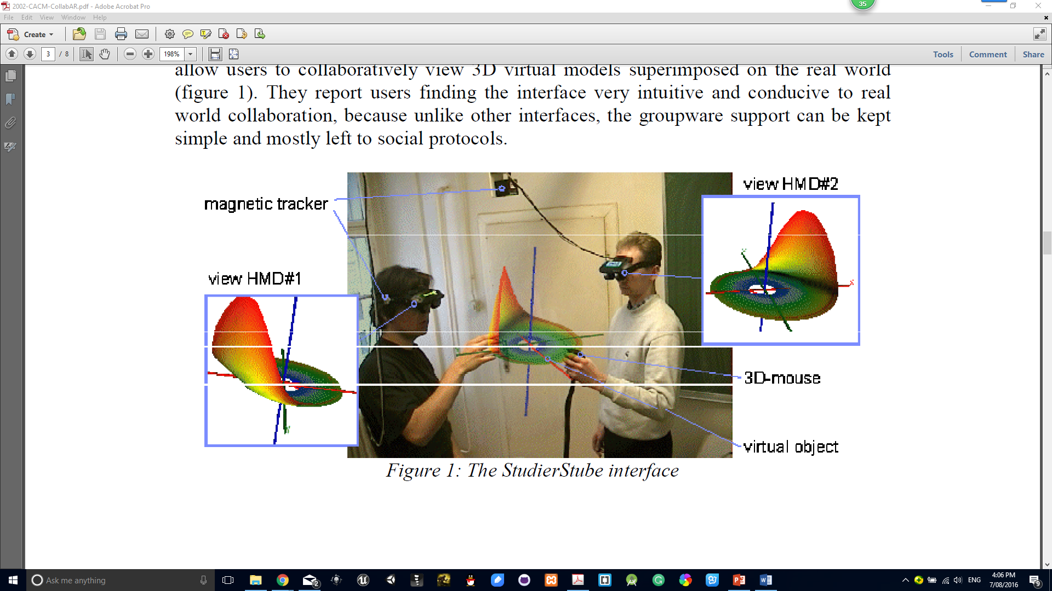

Figure 1: One of the first interfaces to show the potential of AR for face-to-face collaboration (StudierStube project) [2].

For co-located collaboration, AR can be used to enhance a shared physical workspace and create an interface for 3D CSCW [5]. In testing with the Shared Space application, users found the interface very intuitive and conducive to real world collaboration, because unlike other interfaces, the groupware support can be kept simple and mostly left to social protocols [5].

The StudierStube researchers identify five key features of collaborative AR environments:

1. Virtuality: Objects that don’t exist in the real world can be viewed and examined.
2. Augmentation: Real objects can be augmented by virtual annotations.
3. Cooperation: Multiple users can see each other and cooperate in a natural way.
4. Independence: Each user controls his independent viewpoint.
5. Individuality: Displayed data can be different for each viewer.

The value of these characteristics is shown by several user studies that compare collaborative AR interfaces to other technologies. Kiyokawa et. al. [8] have conducted an experiment to compare gaze and gesture awareness when the same task is performed in an AR interface and an immersive virtual environment. Similarly, collaborative AR interfaces can produce communication behaviors that are more similar to unmediated face-to-face collaboration that to screen based collaboration.

Augmented Reality techniques can be used to develop fundamentally different interfaces for face-to-face and remote collaboration. [8] This is because AR provides:

* Seamless interaction between real and virtual environments
* The ability to enhance reality
* The presence of spatial cues for face-to-face and remote collaboration
* Support of a tangible interface metaphor
* The ability to transition smoothly between reality and virtuality

Another important milestone for the combination of VR and Scientific Visualisation was the development of the virtual wind tunnel at NASA-AMES by Steve Bryson. Using a BOOM device and a data gIove as interaction tool [9], scientists were able to see and interact with true stereoscopic images of a flow field visualisation. A follow-up project, the distributed wind tunnel [10] was developed, which divided computation in a distributed system for better efficiency, and allowed multiple users to experience the simulation at the same time. Collaboration in a distributed virtual environment, not necessarily limited to scientific visualisation has been proposed by Fahlen et al [11].

One of the most useful reference project is the collaborative ARvita [7] (Figure 2) developed for the engineering education and practice, which provides a fundamental framework of the collaborate AR software structure (Figure 3).



Figure 2: Two users are observing the animation lying on the table through the ARvita [7].



Figure 3: The software architecture of ARVita conforms to the model-view-controller pattern. The arrow indicates a ‘belongs to’ relationship [7].

### Tracking

Technically, the position of objects is determined by a dedicated tracking sensor, and a representation of the physical model is rendered in background colour to resolve the occlusion problem among physical and virtual objects. Without a highly accurate estimation of the position and orientation of the camera, it is impossible to render a spatially correct overlay of graphical information. Jan Fischer [19] presented a hybrid tracking scheme for medical augmented reality based on a certified medical tracking system.

The ﬁducial marker tracking method and the natural marker tracking method are both options for the tabletop augmented reality software ARvita, where the natural marker offers the advantage of not depending on special predeﬁned visual features.

New opportunities in mobile phone interaction have emerged with the integration of cameras into the phones. By analysing the video stream captured by the camera, using simple image processing on the phone, it is possible to estimate the movement of the device. This can be used in a number of ways such as providing a 6 DOF interface, or recognizing objects to make the phone context aware. Anders Henrysson et al [16] provide the first example of using phone motion to manipulate graphical objects in 6 DOF to create virtual scenes.

Many systems already exist that offer Location Based Services (LBS) with a variety of services (from only visualisation and navigation to update of information) for different applications. Zlatanova [18] presented New ideas for users tracking for LBS, which are motivated by and linked to the OpenGIS Consortium (OGC) specifications for Location Services and related OGC specifications for Web Services in an outdoor AR reality system.

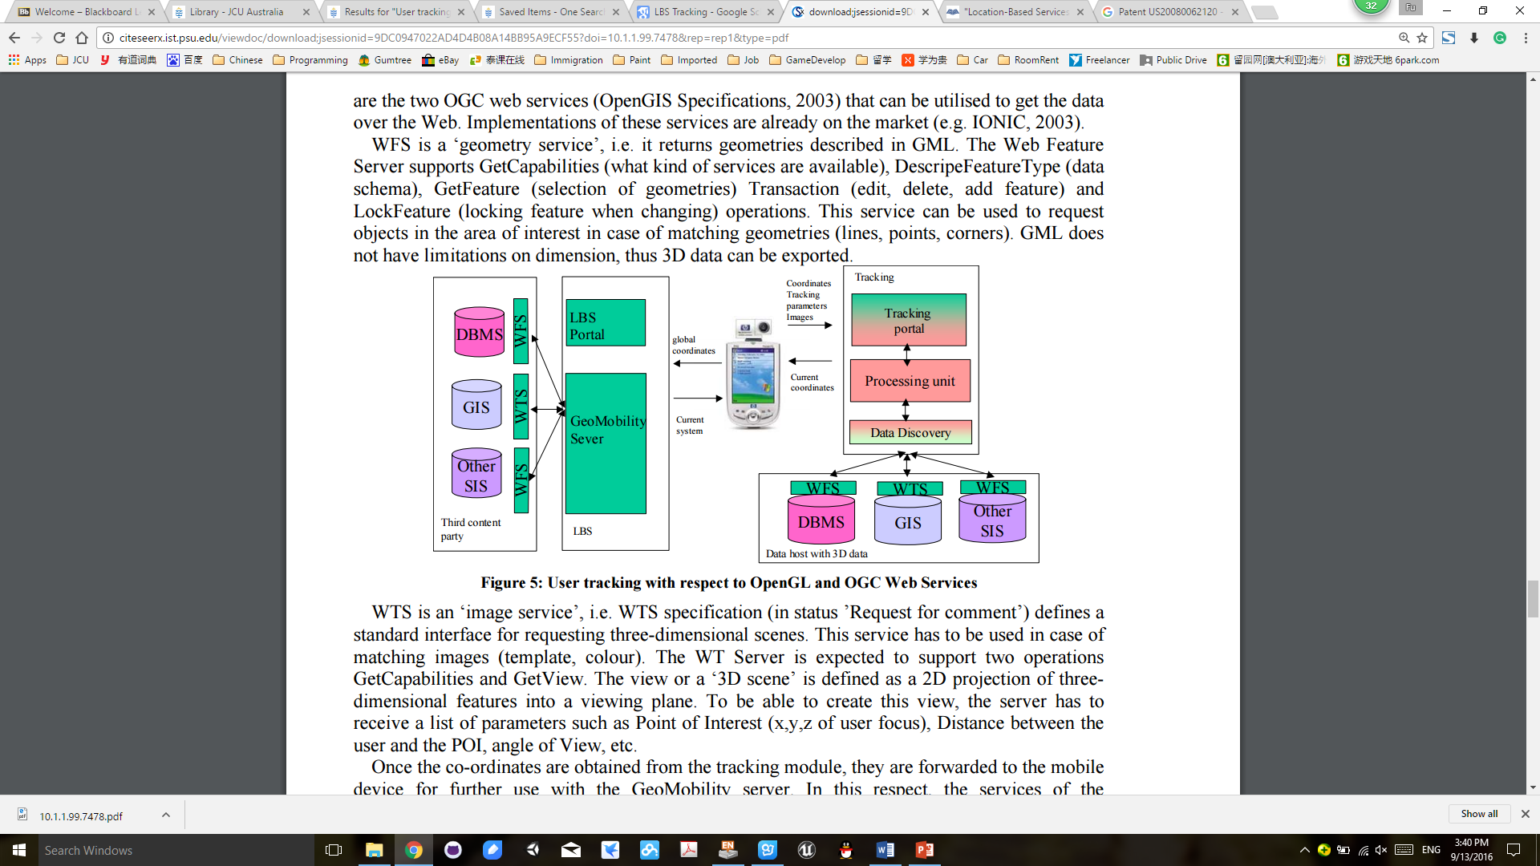

Figure 4: User tracking with respect to OpenGL and OGC Web Services [18].

### CAR applications on mobile phones

Any collaborative augmented reality (CAR) application needs a device equipped with an on-board camera, CPU and display. The most common devices used for CAR applications are Tablet PCs or mobile phones. Mobile phones are more wearable devices than tablet PCs and, therefore, they are more suitable for many CAR applications designed for daily life common situations [17].

The Augmented Reality marker tracking process in CAR applications can be split into four stages, as depicted in Fig. 1: The first stage is denoted as image acquisition stage, and it consists of obtaining an image from the camera’s flow. In the second stage, markers are detected from the image obtained before. Using the position of this markers, the third stage consists of drawing a 3D object on the image. Finally, in the fourth phase, this information (for example, the position(s) of the mark(s)) is sent to the other application nodes through some kind of broadcast communication. The first three phases are similar on any AR application [20], but the last one can be performed by using different technologies like WiFi, 3G or Bluetooth [21]. Although there are some classic CAR applications that uses Bluetooth, usuallyWiFi or 3G technologies are used, since the use of Bluetooth severely limits the spatial range of transmission.

## Problem Definition

While it may be some time before AR technology becomes mature, there are many issues, both technical and social, that should be pursued in the meantime. One of the important aspects is creating appropriate interaction techniques for collaborative AR applications that allow end users to interact with virtual content in an intuitive way. Most existing augmented applications are single user setups or do not exploit the multi-user character of their systems [2]. Exceptions are the CAVE- System [12,13], the Responsive Workbench [14] and the Shared Space [3] which are examples of multi-user augmented reality systems. More recently researchers have begun exploring how mobile AR platforms can be used to enhance face-to-face collaboration. In this case, how to combine these research with the mobile game development needs to be probed furtherly, after all, there are some of the limitations of current collaborative interfaces.

There are shortcomings with most current collaborative technology, especially when used to interact with spatial content [5]. In face-to-face collaboration, people use speech, gesture, gaze and non-verbal cues to attempt to communicate in the clearest possible fashion. However, in many cases, the surrounding real world or real objects play a vital role, particularly in design and spatial collaboration tasks. Besides, none of previous methods can combine the LBS service and Tracking methed together in a single CAR.

In order to overcome these weakness, the collobrative AR application in moblie game should has the following charaterisitcs:

### Multi-users

A situation where multiple users congregate to discuss, design, or perform other types of joint work is categorised as CSCW (computer supported cooperate work) [2]. Much research has been devoted to the question how conventional software and desktop computers can be enhanced with measures to support effective group interaction. Fortunately, a benefit of augmented reality is that sophisticated groupware mechanisms are not needed to perform real work [2]. Normal human interactions (verbal, gestures, etc.) are easily possible in an augmented reality setup, and they are probably richer than any computer-governed interaction can ever be.

### Independence

Unlike the CAVE [13] and the Workbench [14], the control is not limited to a guiding person, while other users act as passive observers. Each user has the option to move freely and independently of the other users. In particular, each user may freely choose a viewpoint with stereoscopy for correct depth perception. But not only is observation independent, interaction can also be performed on a personal base. The semi-immersive character of our augmentation helps to keep human communication channels open, thus improving the quality of collaboration.

### Sharing vs. Individuality

Investigated objects are, in general, shared among users, in the sense of visibility, this means that all participants can see the same coherent model, consistent in its state over time. By presenting the visual sensation directly to each user with the cellphone screen (camera), the displayed data set can also be different for each viewer, as required by the application's needs and the individual's choice. Personal preferences on different layers of information (similar in concept to the ones found in technical illustration programs or CAD packages and the work of Fritzmaurice [15].) can be switched on and off.

### Interaction and Interactivity

With the support of augmented tools, visuatised data can be explored interactively. Changes inherent in the scientific simulation can be viewed immediately. The visual components of the panel in one user’s hand can be kept private, invisible for other users, or public, sharing even 3D information by direct visibility or proiection to projection walls.

### LBS Tracking

Many systems already exist that LBS with a variety of services (from only visualisation and navigation to update of information) for different applications. All of them however rely on GPS positioning [18]. How to use LBS as a tracking method for the CAR is a new field need to be focused on. Technically, a user tracking as it is described above can be realised with the help of OGC Web services.

## Aim

The main aim of the paper is to investigate the trend of collaborative AR technologies application and how to combine them together as well as the influence of mobile phone games on collaboration and social interaction of physically co-located players, instead of focusing on the collaborative AR itself. Evaluate the system performances, user interface performances and the usability of mobile phones for collaborative AR.

## Research Plan and Methodology

The main method used in this research is to review previously published conference papers and other related material. In the future paper, I will provide a comprehensive review of analyzing various tracking methods, interaction techniques and user interfaces in AR, which are very important areas for future research. Then, I will present several research topics presented on the AR and games’ combination. Then, I focus specifically on the important topics of AR tracking, interaction, and display technology, discussing research developments, the main problems explored in the field and current and future AR game research directions.

## Project Plan

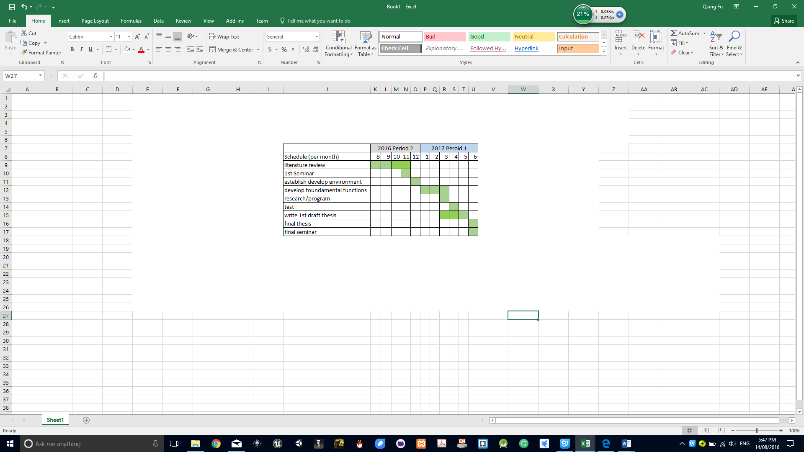

Figure 2: Proposal Research and Writing Timetable

## REFERENCE

1. R.T. Azuma. A survey of augmented reality. Presence: Teleoperators and Virtual Environments 6:4, 355-385, 1997.
2. D. Schmalstieg, A. Fuhrmann, Z. Szalavari and M. Gervautz. 1996. Studierstube-An environment for collaboration in augmented reality. In CVE ’96, 1996.
3. M. Billinghurst, S. Weghorst and T. Furness III. Shared Space: An augmented reality interface for computer supported collaborative work. In CVE ’96, 1996.
4. L.S. Rodrigo Silva. Introduction to augmented reality. http://virtual.lncc.br/~rodrigo/links/AT/no-de 19.html.2003.
5. M. Billinghurst, & Kato, H. (2002). Collaborative augmented reality. NEW YORK: ACM. doi:10.1145/514236.514265
6. Amberā Cruz. Social media ​stats behind Pokémon Go's success. (2016). Retrieved from http://ww-w.pcworld.idg.com.au/article/604606/social-media-stats-behind-pok-mon-go success.html
7. Dong, S., Behzadan, A. H., Chen, F., & Kamat, V. R. (2013). Collaborative visualization of engineering processes using tabletop augmented reality. Advances in Engineering Software,55, 45-55. doi: 10.1016/j.advengsoft.2012.09.001
8. Kiyokawa, K., Takemura, H., & Yokoya, N. (2000). SeamlessDesign for 3D object creation. Ieee Multimedia, 7(1), 22-33. doi:10.1109/93.839308
9. Bryson S. The Virtual Wind Tunnel, In proceedings of IEEE Visualisation'91: 1993; 17-25.
10. Bryson S. The Distributed Virtual Wind Tunnel. In proceedings of Supercomputing '92, also in SIGGRAPH'93 Course Notes. 1992; 43:3.1-3.10.
11. Fahlen LE, Brown CG, Stahl O, Carlsson C. A Space Based Model for User Interaction in Shared Synthetic Environments. In proceedings of tNTERCNI'93:1993; 43-48.
12. Cruz-Neira C, Sandin D, DeFanti T. Surround-Screen Projection-Based Virtual Reality: The Design and Implementation of the CAVE. In proceedings of SIGGRAPH'93: 1993; 135-142.
13. Cruz-Neira C. et al. Scientists in Wonderland: A Report on Visualisation Applications in the CAVE Virtual Reality Environment. In proceedings of the IEEE 1993 Symposium on Research Frontiers in Virtual Reality: 1993; 59-67.
14. Kruger W, Bohn C, Frohlich B, Schuth H, Strauss W, Wesche G, The Responsive Workbench: A Virtual Work Environment. IEEE Computer. 1995; 28: 42-48.
15. Fritzmaurice GW. Situated Information Spaces and Spatially aware Palmtop Computers. Communications of the ACM. 1993; 39:39-49.
16. Henrysson, A., Ollila, M., & Billinghurst, M. (2005). Mobile phone based AR scene assembly. Paper presented at the , 154 95-102. doi:10.1145/1149488.1149504
17. Thomas M. (2007) Emerging technologies of augmented reality: interfaces and design. IGI Global. doi:10.4018/978-1-59904-066-0
18. Zlatanova, S., & Verbree, E. (2004). User tracking as an alternative positioning technique for LBS.
19. Fischer, J., Eichler, M., Bartz, D., & Straßer, W. (2007). A hybrid tracking method for surgical augmented reality. Computers & Graphics, 31(1), 39-52. doi:10.1016/j.cag.2006.09.007
20. Wagner D, Reitmayr G, Mulloni A, Drummond T, Schmalstieg D (2008) Pose tracking from natural features on mobile phones. In: Proceedings of the 7th IEEE/ACMinternational symposium on mixed and augmented reality (ISMAR ’08). IEEE Comput Soc, Los Alamitos, pp 125–134
21. Schmeil A, BrollW(2007) An anthropomorphic AR-based personal information manager and guide. In: Proceedings of the 4th international conference on universal access in human–computer interaction: ambient interaction (UAHCI ’07). Springer, Berlin, pp 699–708